Chapter 12 Notes

Illegal Drug Use Is Dangerous

- Drug abuse is the intentional improper or unsafe use of a drug.
- Drugs used for recreational purposes are called drugs of abuse.
- Many drugs of abuse are illegal drugs. Possessing, using, buying, or selling these drugs is illegal for people of any age.
- Using illegal drugs is not only against the law, it is also dangerous. Here are some of the reasons:
- Illegal drugs can have permanent effects on the brain and the body.
- You can become addicted.
- You can catch infectious diseases from needles.
- You can overdose.
- You can lose the ability to make responsible decisions about other risky behavior.
Why Do People Begin Using Drugs?
- Some of the reasons people try illegal drugs include:
- a desire to experiment
- a desire to escape boredom or depression
- enjoyment of risk-taking behavior
- a belief that drugs solve personal, social, or medical problems
- peer pressure
- glamorization of drugs by the media
Teens and Illegal Drug Use
- Teens have a higher risk of addiction to drugs than adults do because teens’ brains are still developing.
- Drug use or abuse can change the function of the brain.
- Altering brain development with drug use can lead to a life-long struggle to overcome addiction.
Types of Illegal Drugs
- There are many types of illegal drugs, but they all have three things in common.
- They affect the function of the brain.
- They are dangerous to your health.
- They can result in drug dependence and addiction.
- The following slide gives some information about several common illegal drugs and their effects.
Beliefs Vs. Reality
- You or the people around you may have some misconceptions about the dangers of illegal drugs.
- The next slide presents some common beliefs and the facts.
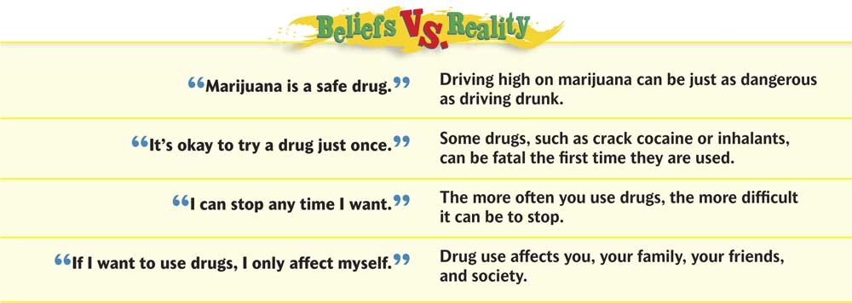

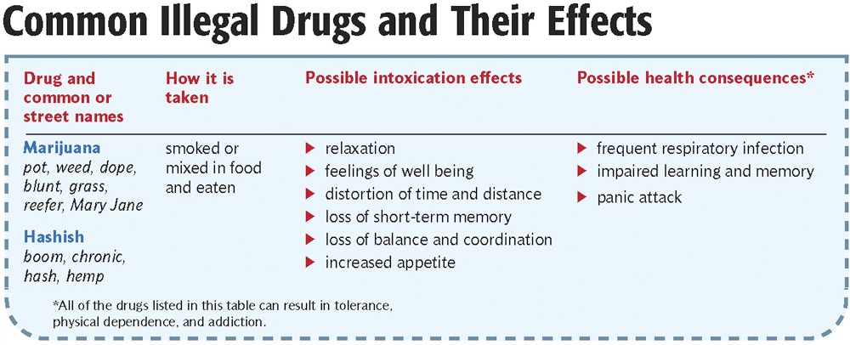

Marijuana
- Marijuana is the dried flowers and leaves from the plant Cannabis sativa.
- The active chemical in marijuana is tetrahydrocannabinol (THC).
- People who use marijuana build up a tolerance, so they need more and more to get high. This can lead to physical dependence.
- Common short-term effects of marijuana include:
- Slowed thinking ability
- Difficulty paying attention
- Distorted sense of time and distance
- Giddiness

- Common short-term effects of marijuana include:
- Loss of short-term memory
- Loss of balance and coordination
- Increased appetite
- Anxiety
- Panic attacks
- Smoking marijuana over a long period has many of the same negative health effects as smoking tobacco.
- Marijuana use is also dangerous when driving. The loss of attention and coordination can make driving high as dangerous as driving drunk.
- Hashish has the same effects as marijuana, but stronger.

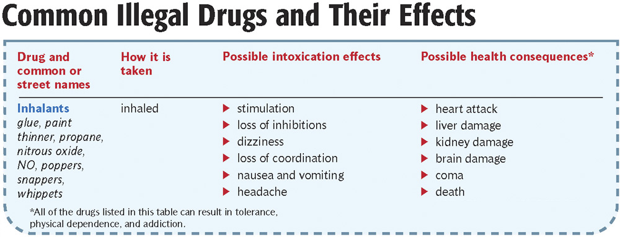

- Inhalants are drugs that are inhaled as vapors.
- Commonly abused inhalants include paint thinner, glue, gasoline, marker fluid, propane, butane, and nitrous oxide.
- Because inhalants are often common products, they can be easy to get and inexpensive.
- Inhalants are a common gateway drug for teens.
Inhalants can be extremely dangerous.
- Inhalants damage many organs.
- Inhalants kill brain cells.
- Inhalants can cause sudden death.

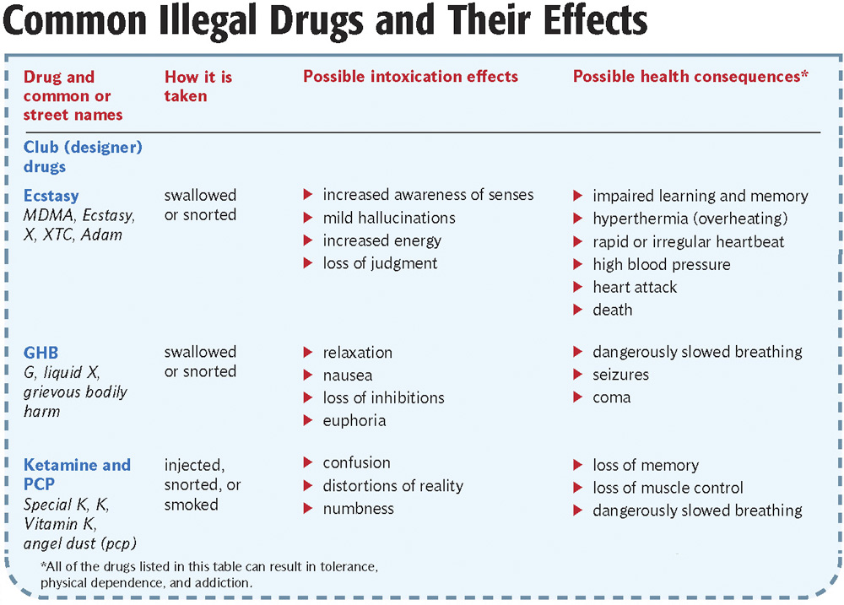

- Club drugs, also called designer drugs, are drugs designed to resemble other illegal drugs in chemical structure and effect.
- Some common club drugs are Ecstasy, GHB, Ketamine, and PCP.

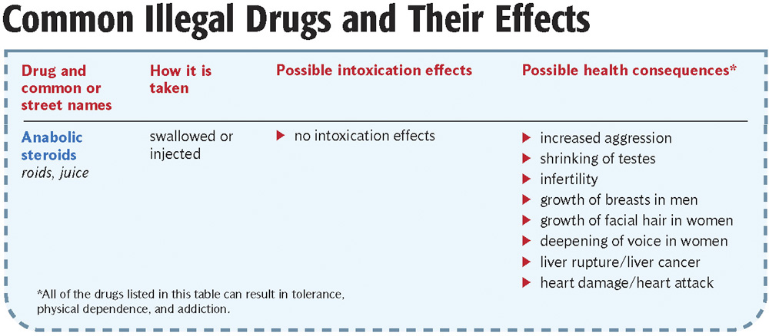

- Anabolic steroids are synthetic versions of the male hormone testosterone that are used to promote muscle development.
- Anabolic steroids have a few legitimate medical uses.
- Most people take anabolic steroids illegally and without guidance from a doctor.
- Unlike most drugs of abuse, steroids have no immediate psychoactive effect. Their primary effects are on the body.

- The table at right shows some of the side effects of anabolic steroids.
- Abusing anabolic steroids can lead to serious health problems.

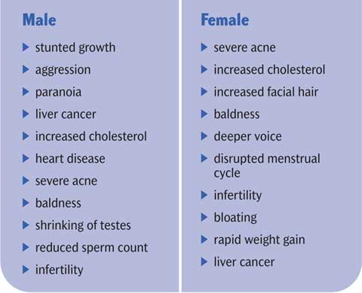

Self-Esteem
- One reason some athletes choose to use steroids is that they don’t believe that their natural talent and hard work is good enough.
- Peer pressure can also play a role in why someone starts using illegal drugs.
- Healthy self-esteem can help people resist these pressures.

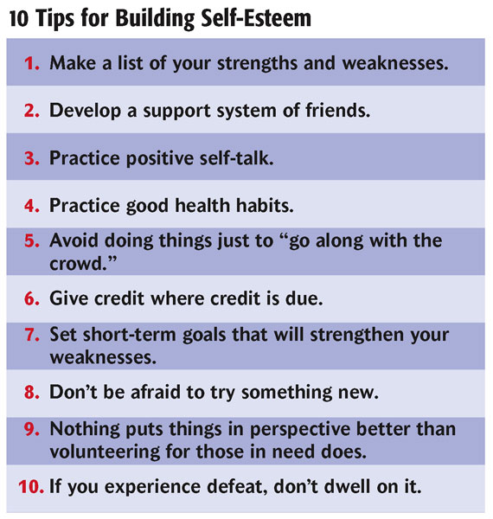

Other Types of Abused Drugs
- Stimulants are drugs that temporarily increase a person’s energy and alertness.
- Depressants are drugs that cause relaxation and sleepiness.
- Opiates are a group of highly addictive drugs derived from the poppy plant that are used as pain relievers, anesthetics, and sedatives.
- Hallucinogens are drugs that distort perceptions and cause a person to see or hear things that are not real.

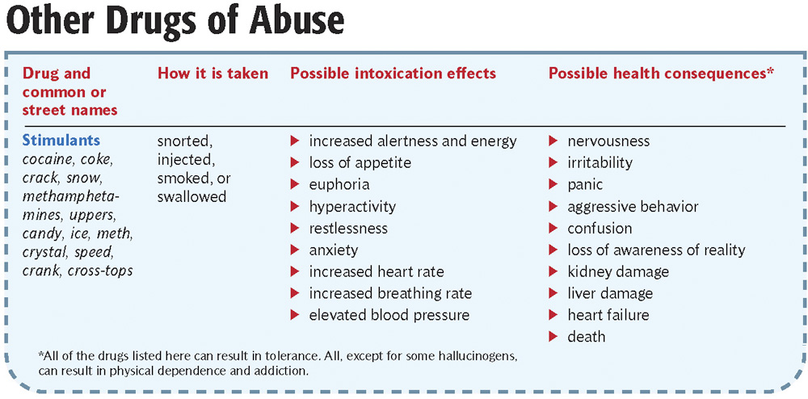

Stimulants
- Caffeine and nicotine are mild, legal stimulants, although they are addictive.

- Amphetamines are a group of stimulants produced in laboratories. They are highly addictive. Repeated use can cause severe damage to the body and brain.
- Cocaine and crack cocaine are stimulants derived from the coca plant. They are also highly addictive. Overdose of these drugs can be very dangerous.

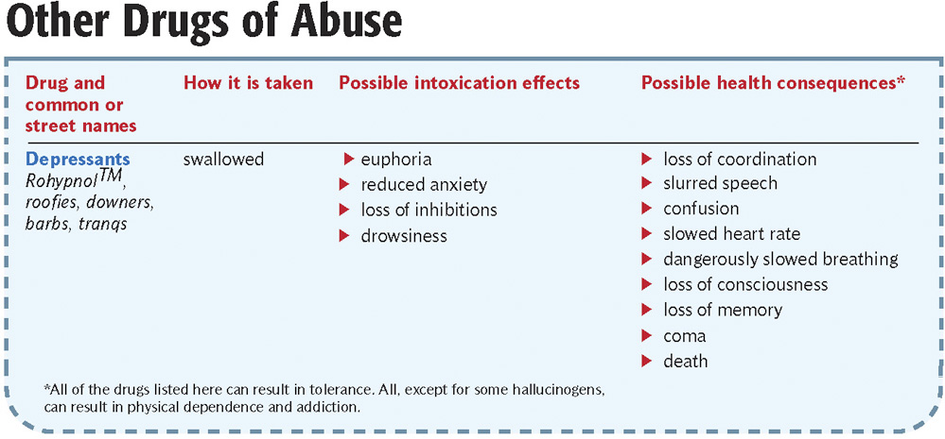

- Depressants have effects similar to the effects of alcohol. They are highly addictive when abused.
- Using depressants in combination with alcohol increases the effects.
- Overdose may cause brain damage, coma, or death.
- Rohypnol is a hypnotic widely used as a date-rape drug.
- Dextromethorphan (DXM) is an ingredient in cough syrups. In high doses its effects are similar to the effects of PCP.
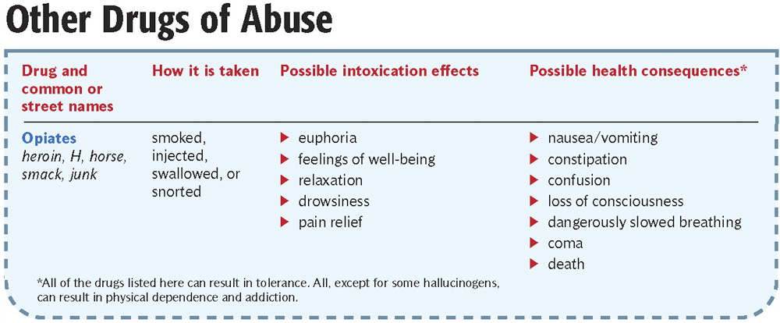

- Opiates, such as morphine and codeine, can be very effective medicines when used properly in limited amounts.
- Opiates reduce pain, relieve diarrhea, suppress coughing, and induce relaxation.
- When abused, opiates result in addiction very quickly. Withdrawal symptoms are severe.

- Heroin is a chemically altered form of morphine.

- Heroin is highly addictive. This addiction is debilitating and often ruins people’s lives.

- Heroin addicts frequently:
- lose their jobs
- have poor living conditions
- suffer many health problems
- choke on their own vomit when passed out
- catch diseases from needles
- engage in crime to support their addiction

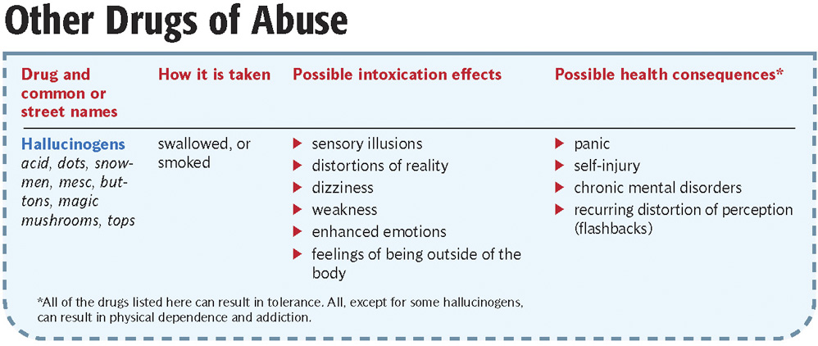

Hallucinogens
- LSD is usually taken as tablets or absorbed through the tongue on small paper squares.

- LSD can increase energy, alter mood, and produce strange sensations or hallucinations. The effects of LSD can also be frightening.
- Mushrooms are a naturally poisonous species of mushroom that produce effects similar to LSD.

- LSD and mushroom users can experience flashbacks long after they have taken the drugs.

Refusal Skills

- Practicing your refusal skills can make you more confident in your decision to refuse drugs if they are ever offered to you.

- Use the next slide to review your skills.

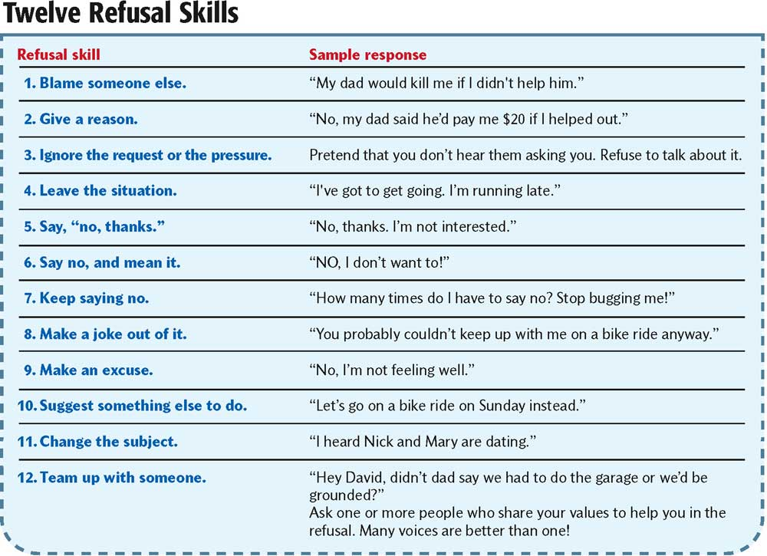

Drug abuse Affects the Individual
- The dangers of intoxication, side effects, and addiction are not the only risks of drug abuse.
- Other risks include:
- car accidents
- accidental injury or death
- violence and other criminal activity
- unplanned pregnancy
- sexually transmitted diseases
Drug Abuse Affects the Family
- When a teen or other family member is using drugs, it destroys trust within the family.
- Drug abuse often leads to family violence.
- Drug use can be dangerous to pregnant women and to the fetus.
- Neonatal abstinence syndrome is withdrawal that occurs in newborn infants whose mothers were frequent drug users during pregnancy.
Drug Abuse Affects Society
- Like the use of tobacco and alcohol, drug use imposes economic costs on society.
- Billions of dollars are spent in the U.S. each year on health care resulting from drug abuse.
- There are also costs from lost productivity at work, accidents, suicide, and other drug-related problems.
- Drug abuse and addiction also increase crime.
- 1 out of every 4 prisoners is in jail for a drug-related crime.
Treatment for Drug Addiction
- Recovering is the process of learning to live without drugs.
- Because drugs affect the brain, recovering from addiction is very difficult and usually requires treatment and extensive support.
- Drug treatment approaches include 12-step programs, outpatient counseling, and residential communities.
Principles for Effective Drug Treatment
- No single treatment works for everyone.
- Treatment should be available and easy to access.
- The best treatment also addresses problems other than addiction.
- Treatment should offer multiple services.
- The longer an abuser stays in treatment, the more effective it is.
- Group therapy builds skills for resisting drugs and developing relationships without drugs.
- Medications can be an important part of treatment.
- Mental illness should be treated along with addiction.
- Treatment does not need to be voluntary.
- Patients should be monitored.
- Programs should test for HIV/AIDS, hepatitis, and other diseases.
- Recovery may require several periods of treatment to combat relapse.
Saying No to Drugs
- As with alcohol, tobacco, and other pressures, you should practice and be ready to say “No” to drugs.
- Say no firmly.
- Buy yourself time.
- Give good reasons.
- State the consequences.
- Say no again and include an alternate activity.
- Walk away.
What to Say
- People who use drugs often use similar “lines” when pressuring other people to join them. The following slide will give you some ideas of how you can respond.



