Notes Chapter 10 (Lecture Slides)

Alcohol Is a Drug
- Alcohol is the drug found in beer, wine, and liquor that causes intoxication.
- Intoxication includes all the physical and mental changes produced by drinking alcohol
Short-Term Effects of Alcohol
- Effects on the Body
- Alcohol irritates the mouth, throat, esophagus, and stomach.
- Alcohol makes the heart work harder.
- Alcohol makes the body lose heat.
- Alcohol causes the liver to work harder.
- Alcohol causes dehydration.
- Effects on the Mind
- Alcohol slows down the nervous system.
- The drinker loses inhibitions.
- The drinker cannot focus his or her eyes.
- The drinker may have slurred speech.
- The drinker loses coordination and judgment.
- Blood alcohol concentration (BAC) is the amount of alcohol in a person’s blood expressed as a percentage.
- Alcohol has different effects at different BACs.
- Binge drinking is the act of drinking five or more drinks in one sitting.
- Binge drinking can lead to alcohol poisoning, and can be fatal.

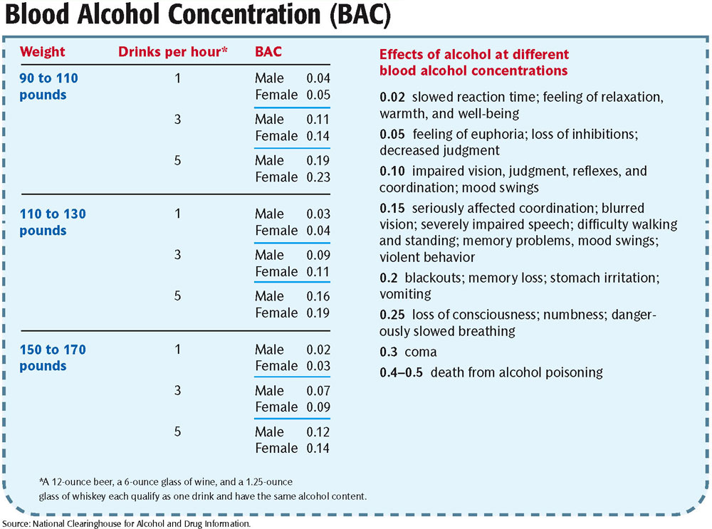

Long-Term Effects of Alcohol
- Prolonged use of alcohol can damage the heart, blood, liver, kidneys, pancreas, the digestive tract, and the immune system.
- Cirrhosis is a disease caused by long-term alcohol use in which healthy liver tissue is replaced with scar tissue.
- Alcohol causes permanent changes in the brain due to cell death from dehydration and lack of oxygen.
- Alcoholism is the second leading cause of dementia in the United States.
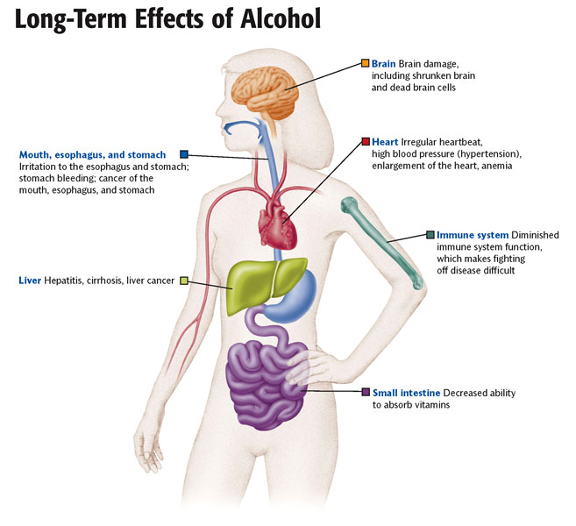
What Is Alcoholism?
- Alcohol abuse is drinking too much alcohol, drinking it too often, or drinking it at inappropriate times.
- Alcoholism is a disease that causes a person to lose control of his or her drinking behavior.
- Alcoholics are physically and emotionally addicted to alcohol, and suffer painful symptoms when they do not have alcohol.
Alcoholism Develops in Stages
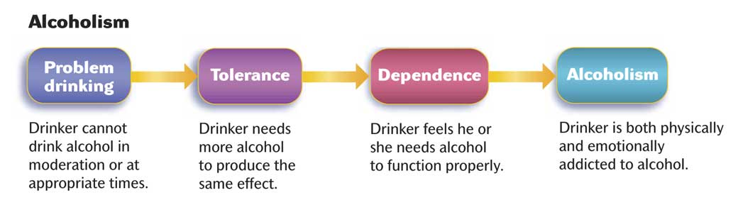
- Risk factors for alcoholism include:
- Age
- Social environment
- Genetics
- Risk-taking personality
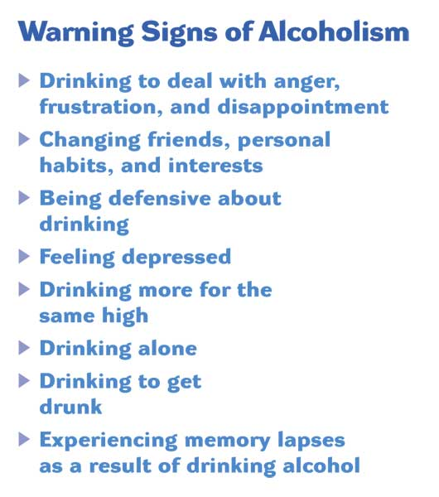
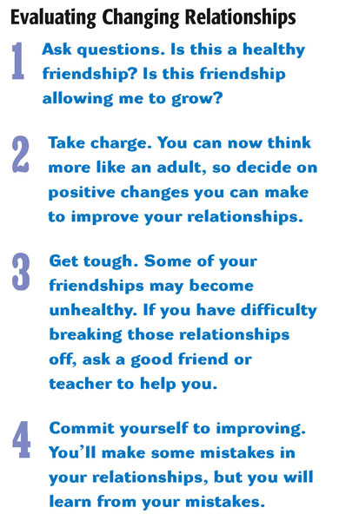
Alcoholism Affects the Family
- Families of alcoholics may suffer from the following:
- Guilty feelings
- Unpredictable behavior
- Violence
- Neglect and isolation
- Protecting the alcoholic
- Ignoring one’s own needs
- Enabling means helping an addict avoid the negative consequences of his or her behavior.
- Codependency is the condition in which a family member or friend sacrifices his or her own needs to meet the needs of an addict.
- Fetal alcohol syndrome (FAS) is a set of physical and mental defects that affect a fetus that has been exposed to alcohol because of the mother’s alcohol consumption while pregnant.
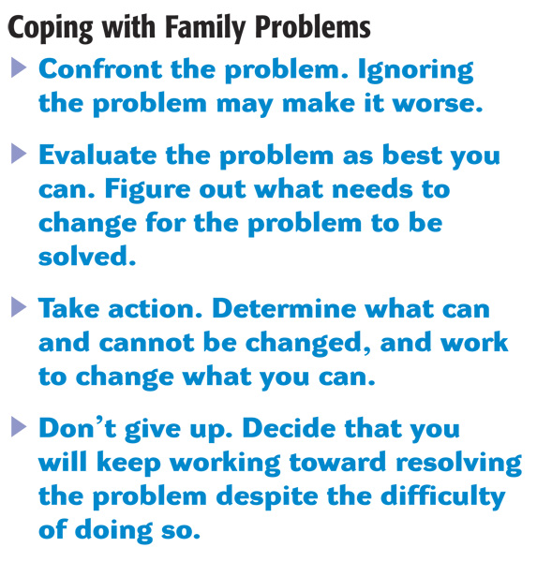

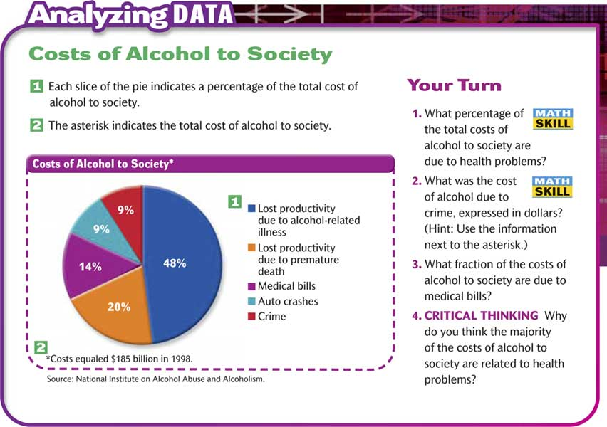

Alcoholism Can Be Treated
- There are many treatment options for alcoholics.
- Alcoholics Anonymous (AA) is the most widely used program. It involves a 12-step recovery method and regular meetings.
- Al-Anon and Alateen provide treatment and support for people with alcoholics in their family.
Drinking and Driving: A Deadly Combination
- Motor vehicle accidents are the leading cause of death among teens.
- Many of these accidents are alcohol-related.
- Alcohol impairs driving through the following means:
- Slows your reaction time
- Affects your vision
- Makes you drowsy
- Reduces your coordination
- Affects your judgment
Drinking and Driving: A Deadly Combination
- Alcohol use is illegal for people under 21.
- Driving under the influence (DUI) applies to anyone with a BAC above 0.08.
- The law has zero tolerance for anyone under 21 driving with any amount of alcohol in their blood.
- To avoid getting in dangerous situations with an intoxicated driver:
- Don’t drink
- Plan ahead: pick a designated driver
- Make arrangements with a parent for a ride
- Call a cab
Drinking Puts Your Future at Risk
- Drinking and Jail You can be sent to jail for trying to buy alcohol, possessing alcohol, possessing a fake ID, or for drinking in a public place.
- Drinking and Sexual Activity The impaired judgment from drinking can put you at risk of any of the dangers of unplanned sexual activity.
- Drinking and Diving Alcohol plays a role in more than 38 percent of drowning accidents in the U.S.
- Drinking and Teen Brains Alcohol use affects the rapidly developing brains of teens.
Saying No to Alcohol
- The best way to avoid alcohol is to stay away from people who drink and places where people are drinking.
- You should practice ways of saying “No” so you will be prepared when someone offers you a drink.

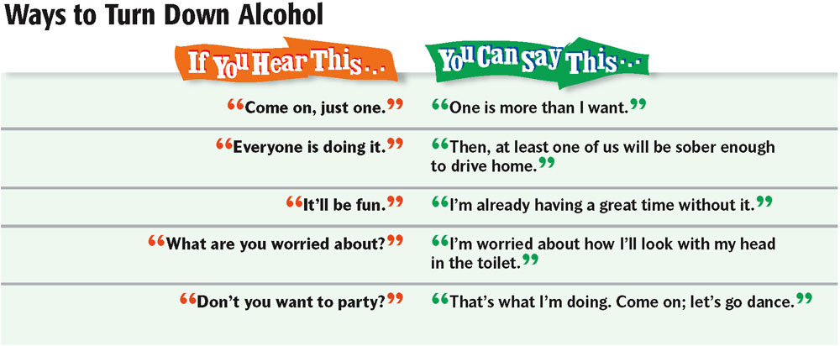
Building Self Esteem
- A healthy self-esteem helps you resist pressure to do things you know are unhealthy.
- The next slide reminds you of ways to build your self-esteem.
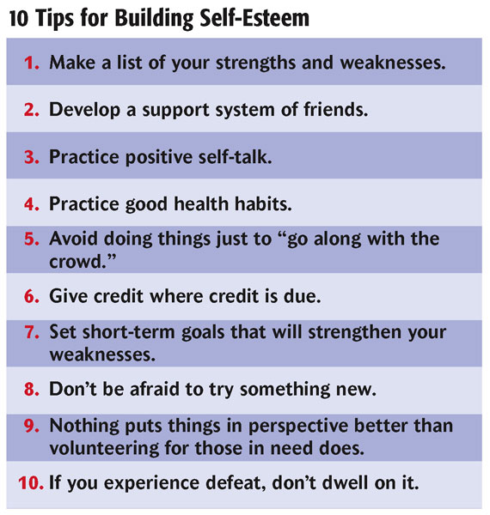

Saying No to Alcohol
- Practicing your refusal skills makes it easier to refuse alcohol if it is offered to you.
- The next slide provides a review of your refusal skills.

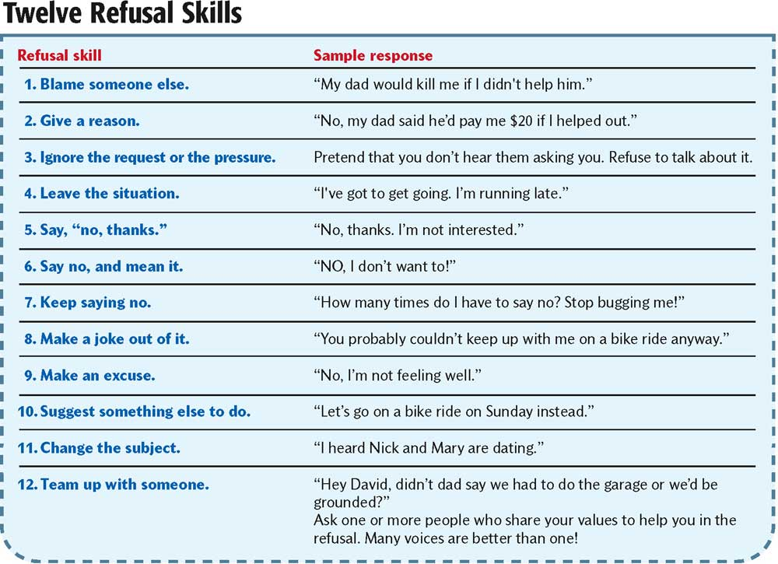

Making GREAT Decisions
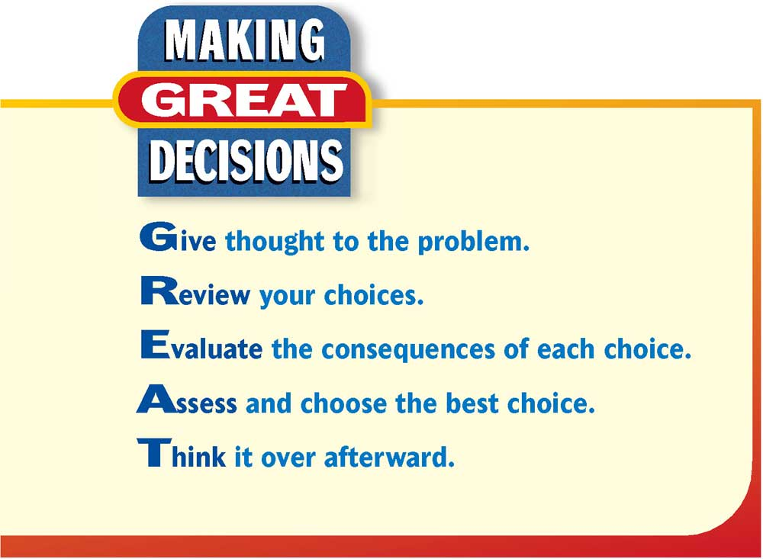

Building Resiliency
- Being offered alcohol can be a stressful situation. Resilient people continue to be optimistic when life gets tough. The next slide provides eight skills to help build your resiliency.

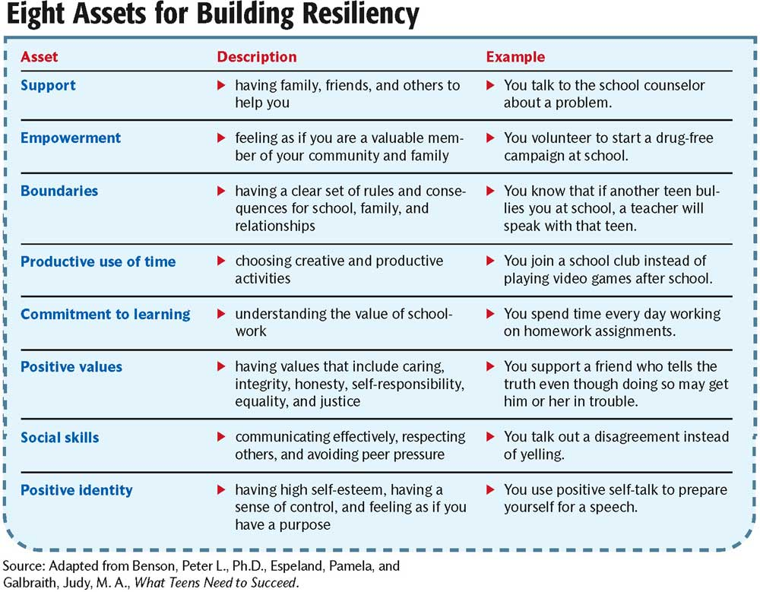

Joining the Fight Against Drunk Driving
- Two organizations that spread information and work to end problems with drunk driving are:
- Mothers Against Drunk Driving (MADD)
- Students Against Drunk Driving (SADD)

